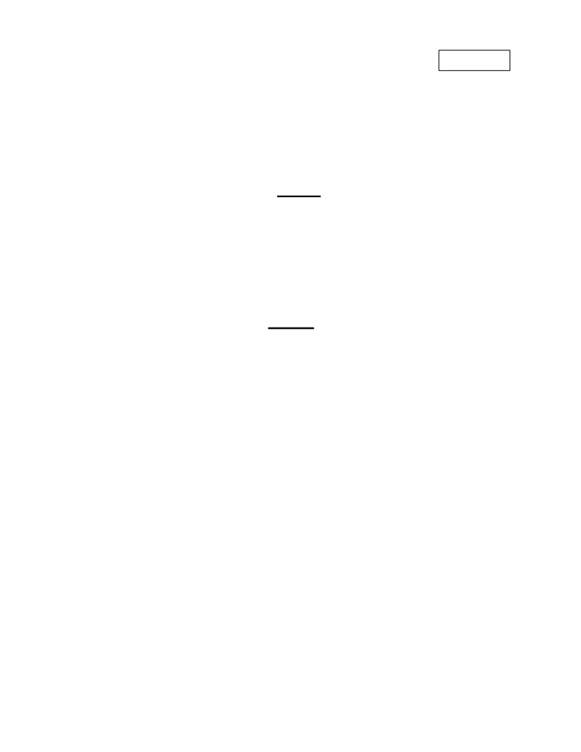

Subject Code: R13105/R13 Set No - 1
I B. Tech I Semester Regular/Supplementary Examinations Jan./Feb. - 2015
COMPUTER PROGRAMMING
(Common to CE, ME, CSE, PCE, IT, Chem E, Aero E, AME, Min E, PE, & Metal E)

Time: 3 hours
Question Paper Consists of Part-A and Part-B
Answering the question in Part-A is Compulsory,
Three Questions should be answered from Part-B
**
PART-A
1.(i) C is a structured programming language. Explain.
(ii) Discuss about nested if with example.
(iii) What are header files? Explain.
(iv) Differentiate between pointer variable and normal variable.
(v) Explain about bit fields.
(vi) Write a short notes on files.

PART- B

2.(a) List and Explain different types of operators in C.
(b) Write a program to find primes in the given range.

3.(a) Explain any two iterative statements with examples.
Max. Marks: 70

[3+4+4+4+3+4]

[8+8]

(b) Write a program for calculating the length of a string without using string handling

functions.

[6+10]

4.(a) What is the difference between recursive and non-recursive functions? Give their merits

and demerits.

(b) Write a recursive function for finding the factorial value of a given number.

[8+8]

5.(a) How pointers can be used for declaring of multi dimensional arrays? Discuss.

(b) Write a program to multiply two matrices using pointer.

[8+8]

6.(a) Write a short notes on unions within structures.

(b) Write a program to create a linked list.

[8+8]

7.(a) Discuss about unformatted I/O with suitable examples.

(b) Write a program to print file contents in reverse order.

[8+8]

Page 1 of 1

||''|'''|''|''|'''||

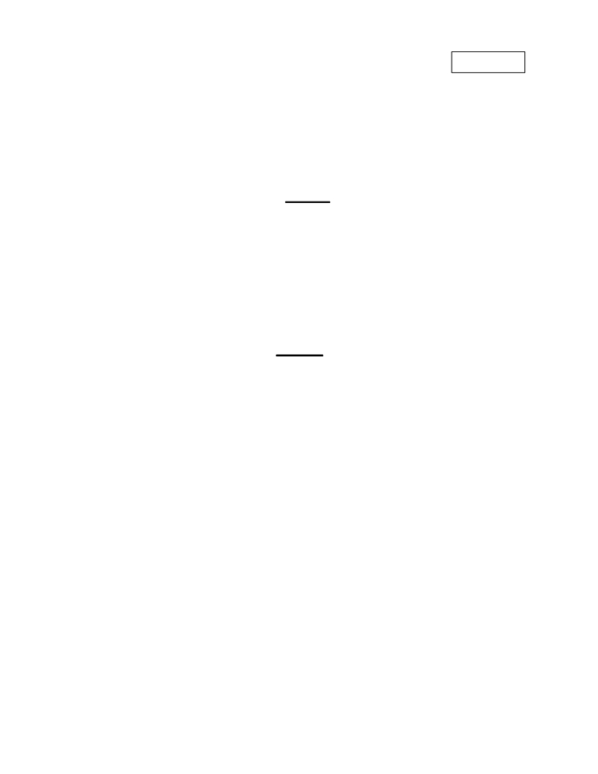

Subject Code: R13105/R13 Set No - 2
I B. Tech I Semester Regular/Supplementary Examinations Jan./Feb. - 2015
COMPUTER PROGRAMMING
(Common to CE, ME, CSE, PCE, IT, Chem E, Aero E, AME, Min E, PE, & Metal E)
Time: 3 hours Max. Marks: 70
Question Paper Consists of Part-A and Part-B Answering the question in Part-A is Compulsory, Three Questions should be answered from Part-B
**
PART-A

1.(i) What is pseudo code? Explain.
(ii) Differentiate between break and exit.
(iii) Explain about block structure.
(iv) What is indirect pointer? Dicuss.
(v) What is union? Explain.
(vi) Write a program to read a text file and to print the count the no of tab characters in a
given file.
[2+4+4+4+4+4]
PART- B

2.(a) What is a datatype? Discuss about the range for different data types.
(b) Write a program to find the sum of the series: 1+2²+3²+……
[8+8]
3.(a) Differentiate between iteration and branching.
(b) Write a program to print the day of the week using switch and else-if and also give the
comparison between using of switch and else-if.
[8+8]
4.(a) What is user defined functions? Discuss with an example.
(b) Write a recursive function to find GCD value.
[8+8]
5.(a) What is copy by value and copy by address? Discuss.
(b) Write a program to illustrate passing by address example.
[8+8]
6.(a) Explain about the bitwise operators with examples.
(b) Write a program find the one’s compliment for the given number.
[8+8]
7.(a) How to read from and write to a file? Explain with examples.
(b) Write a program to find the n^{th} occurrence of a given word in a given file.
[8+8]

Page 1 of 1

||''|'''|''|''|'''||

Subject Code: R13105/R13 Set No - 3
I B. Tech I Semester Regular/Supplementary Examinations Jan./Feb. - 2015
COMPUTER PROGRAMMING
(Common to CE, ME, CSE, PCE, IT, Chem E, Aero E, AME, Min E, PE, & Metal E)
Time: 3 hours Max. Marks: 70
Question Paper Consists of Part-A and Part-B Answering the question in Part-A is Compulsory, Three Questions should be answered from Part-B
**
PART-A
1.(i) Explain about enum data type.
(ii) Differentiate between do-while and for loop.
(iii) Explain about C Preprocessor with an example.
(iv) What are actual and former parameters.
(v) What is left shift? How is it different from right shift?
(vi) Write a program to read a text file and to count the no of uppercase letters in a given file.
[4+4+3+4+3+4]
PART- B

2.(a) What is algorithm? Write an algorithm and flowchart for the finding the given no is
Armstrong no or not?
(b) Write a C program to calculate the total of the series: 1+(1/2²)+(1/3²)+…..
[8+8]
3.(a) Differentiate between string and array? What are the applications of an array? Discuss.
(b) Write a program to find the value.
[8+8]
4.(a) Explain about call by value and call by reference mechanisms.
(b) Write a non recursive program for calculating the factorial of a number using functions.
[8+8]

5.(a) What is the importance of * and **? Explain about the initialization and declaration of
pointer variables.
(b) Write a program for illustrating the dynamic memory allocation.
[8+8]
6.(a) Explain about Structures and functions.
(b) Write a program to illustrate structures and functions.
[8+8]
7.(a) What is file? Explain about the Input and output functions of files.
(b) Write a program to illustrate file operations.
[8+8]
Page 1 of 1

||''|'''|''|''|'''||
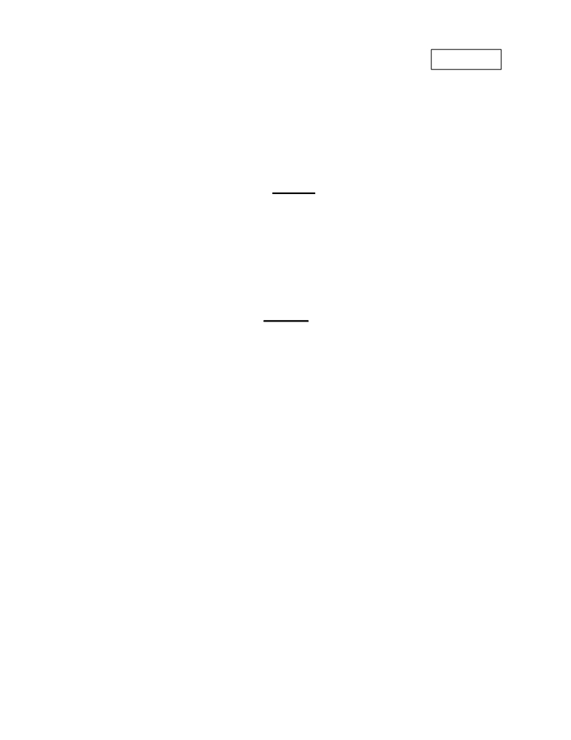

Subject Code: R13105/R13 Set No - 4
I B. Tech I Semester Regular/Supplementary Examinations Jan./Feb. - 2015
COMPUTER PROGRAMMING
(Common to CE, ME, CSE, PCE, IT, Chem E, Aero E, AME, Min E, PE, & Metal E)
Time: 3 hours Max. Marks: 70
Question Paper Consists of Part-A and Part-B Answering the question in Part-A is Compulsory, Three Questions should be answered from Part-B
**
PART-A
1.(i) How to execute c program in linux? Explain with example.
(ii) Differentiate between do-while and while-do.
(iii) Differentiate between 1D and 2D arrays.
(iv) Explain about character pointer.
(v) Discuss about rotation.
(vi) What is binary file? Discuss
[4+4+3+4+3+4]
PART- B

2.(a) Differentiate between hardware and software.
(b) Explain about the history of the C programming language.
(c) Write a C program that illustrates the unary operators.
[4+6+6]
3.(a) What is an array? What are the disadvantages of an array? Discuss. (b) Write a program to print the following matrix on the screen.
a b c d e
f g h i j
k l m n o
p q r s t [8+8]

4.(a) Explain about different storage classes with examples along with scope rules.
(b) Write a program to print Pascal triangle using functions. [8+8]

5.(a) Differentiate between direct and indirect pointers with examples.
(b) Write a program to illustrate pointers. [8+8]

6.(a) What is union? How to declare and initialize unions? Discuss.
(b) Write a program to find two’s compliment for the given no. [8+8]

7.(a) What are different types of operating modes of files? Explain with an example.
(b) Write a program to copy one file contents into another file in reverse order. [6+10]
Page 1 of 1

